**WORKING INSTRUCTIONS**

|  |  |
| --- | --- |
| **Doc Nr.:** | **NCT LAB** |
| **Version:** | **Continental TCI, Bangalore** |
| **Impl. Date:** | **Model: Oscilloscope** |

|  |
| --- |
| **Safety Instructions/ ESD/3S** |
| 1. **Always follow working instruction** 2. **Clean the machine table before usage and clean the equipment if any dirt and dust found.** 3. **After completing the work do not keep the fixtures, test components on the machine table.**      |  |  |  | | --- | --- | --- | | **S1 (Seiri)** | **S2 (Seiton)** | **S3 (Seisou)** | | **Prepare needed tools** | **Keep everything tidy** | **Always keep clean** | |

|  |
| --- |
| **Unusual Case** |
| **If the equipment functions abnormally, e.g. strange sounds, warning signal or something looks unusual:**   |  | | --- | | **Stop machine – Inform - Waiting** |   **Stop the machine**  **Inform to the lab incharge**  **Wait for the decision** |

**Oscilloscope**

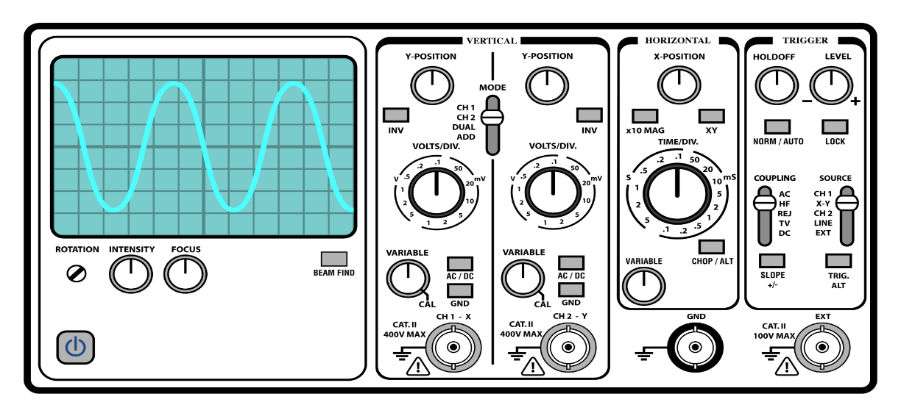

**Safety labels on products:**

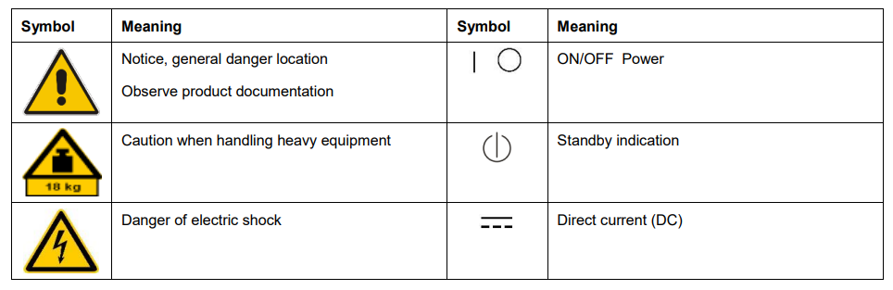

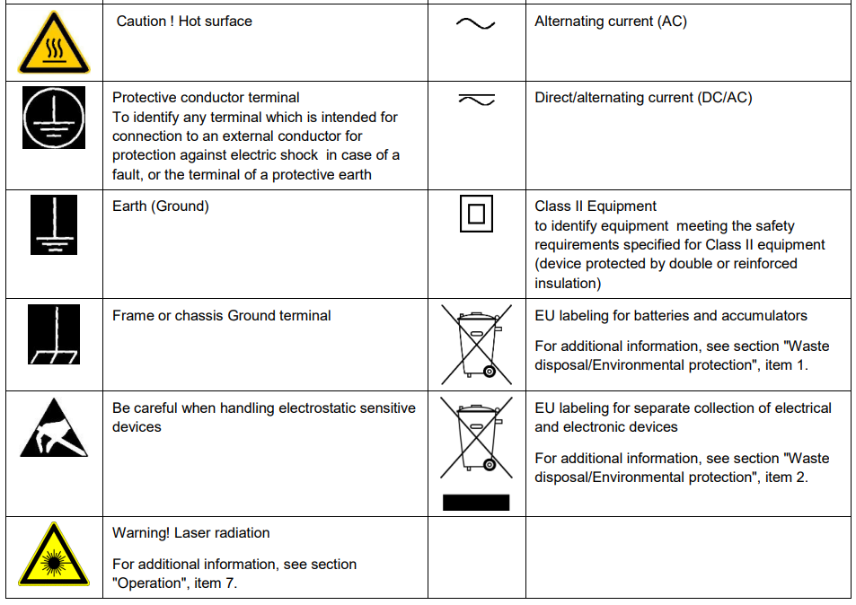

**Risk of instrument damage during operation:**

An unsuitable operating site or test setup can damage the instrument and connected devices. Ensure the following operating conditions before you switch on the instrument:

* Make sure that the nominal voltage setting on the product matches the nominal voltage of the AC supply network.
* Never use the instrument in dusty or damp conditions, in an explosion hazard area, or near aggressive chemicals. The ambient temperature and humidity must not exceed the ranges specified for the equipment.
* The instrument should be dry and shows no sign of condensation.
* The instrument can only be operated with a properly grounded safety socket outlet.
* Never use a cheater plug or other means to defeat or disconnect the protective ground lead.
* Check the power cable for damage and replace it if necessary. The power cord must be plugged in before signal circuits are connected.
* Before each measurement, check the instrument for proper operation using a known signal source or sample.
* Signal levels at the input connectors are all within the specified ranges.
* Signal outputs are correctly connected and are not overloaded.

**Safely rotate the handle**

Use the correct process to eliminate the chance of pinching your thumb or rear-panel-connected cables while rotating the handle.

**CAUTION**.

Hold the top of the handle to rotate the handle on the instrument. Do not hold the handle from the sides and rotate, as this can pinch the base of your thumb between the handle and the case.

If you have routed any cables between the handle and the case, be careful when rotating the handle so that you do not pinch the cables.

**Operating requirements**

Use the oscilloscope within the required operating temperature, power, altitude, and signal input voltage ranges to provide the most-accurate measurements and safe instrument operation.

**Environment requirements**

|  |  |
| --- | --- |
| **Characteristic** | **Description** |
| Operating temperature | 0 °C to +50 °C (+32 °F to +122 °F)  For proper cooling, keep the sides and rear of the instrument clear of obstructions for 2 inches (51 mm). |
| Operating humidity | 5% to 90% relative humidity (% RH) up to +40 °C (+104 °F)  5% to 55% RH above +40 °C up to +50 °C (+104 °F to +122 °F), Noncondensing |
| Operating altitude | Up to 3000 meters (9842 feet) |

**Powering the oscilloscope:**

Use this procedure to connect the oscilloscope to line power and power on and off the oscilloscope. Always connect the oscilloscope to AC power using the power cord that shipped with the instrument.

Prerequisite: Use the AC power cord that shipped with your oscilloscope.

1. Connect the supplied power cord to the oscilloscope power connector.

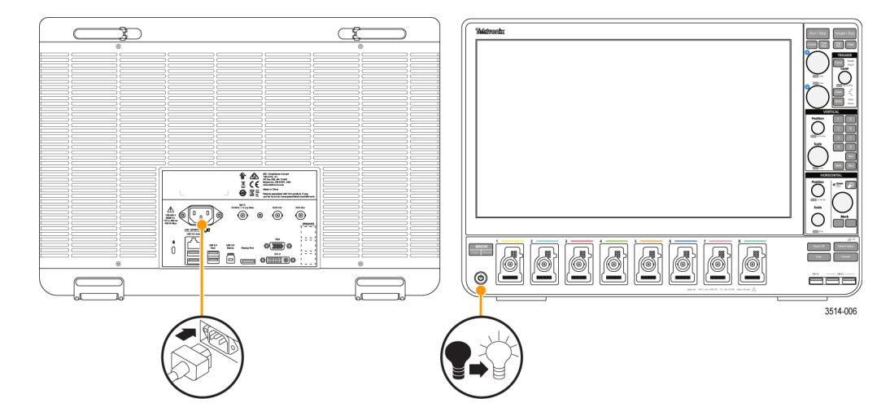

2. Connect the power cord to an appropriate AC mains source. Power is supplied to the power supply and some other boards whenever the AC power cord is connected to a live mains circuit, putting the instrument in standby mode.

3. Push the front panel power button to power the instrument on and off. The power button indicates instrument power states: No light – no AC power applied Yellow – standby mode Blue – powered on

4. To completely remove power from the instrument, disconnect the power cord.

5. To transport the instrument with its power cord, flip out the power cord supports on the upper edge of the rear panel and wrap the power cord around the supports.

**Check that oscilloscope passes power-on self tests:**

1. Power-on self tests verify that all oscilloscope modules are working correctly after power up.
2. Power on the oscilloscope and wait until the oscilloscope screen appears.
3. Select Utility > Self Test from the top-edge Menu bar to open the Self Test configuration menu.
4. Check that the power-on self tests are Passed

5. If the power-on self test shows Failed:

a. Power cycle the oscilloscope.

b. Tap Utility > Self Test. If the power-on self test still shows Failed, contact Tektronix Customer Support.

**Secure (lock) the oscilloscope:**

Lock an oscilloscope to a test bench or equipment rack to prevent property loss.

Attach a standard laptop security lock to the rear panel of the oscilloscope, to secure the oscilloscope to a workbench, rack, or other location.

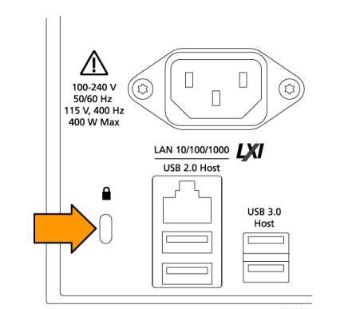

**Connecting Probes :**

Probes and cables connect the oscilloscope to your device under test (DUT). Use a probe that best matches your signal measurement needs.

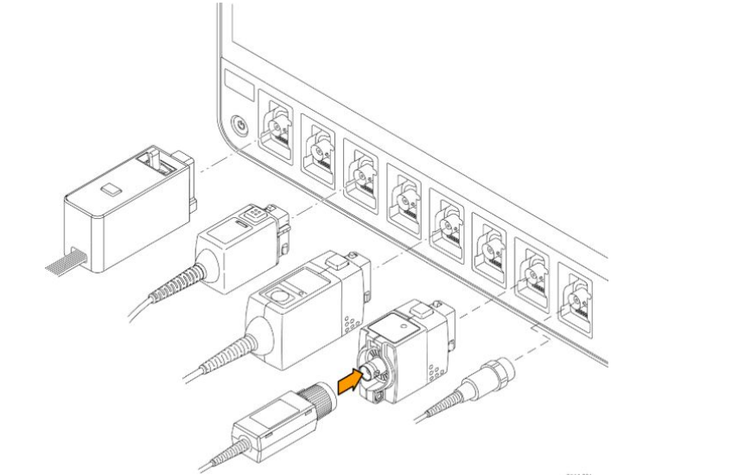

Connect TPP0500, TPP1000, TekVPI+® , TekVPI® , or other supported Tektronix analog probes by pushing them into a FlexChannel connector.

The probe base latch locks with a 'click' when the probe is fully seated. TekVPI probes automatically set the channel input parameters for that probe (bandwidth, attenuation, termination, and so on).

If a probe has a Menu button, push that button to open an on-screen configuration menu. Follow instructions provided with active probes to set their parameters (auto zero, degauss, and so on).

To connect a TLP058 FlexChannel Logic Probe:

* Move the locking lever to the unlocked position, then let go to reset locking lever to the center position.
* Insert the probe into a FlexChannel channel until fully seated and the lock mechanism clicks.
* Move the locking lever to the locked position. The status light should be a solid green.
* To disconnect the TLP058 probe, move and hold the locking lever at the unlocked position and pull out the probe. Do not pull on the ribbon cable while removing the probe.

**Front Panel :**

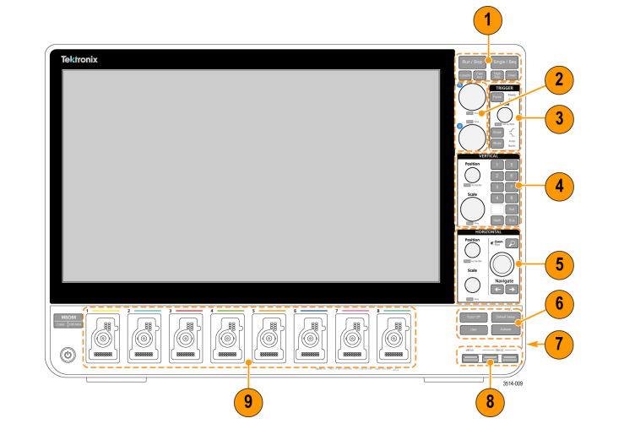

**1. Acquisition and Cursors controls:**

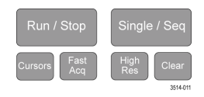

■ **Run/Stop** starts and stops waveform acquisition. The button color indicates the acquisition status (green = running and acquiring; red = stopped). When stopped, the oscilloscope shows waveforms from the last completed acquisition. The Run/Stop button on the screen also shows the acquisition status.

■ **Cursors button** turns screen cursors on or off. Use the Multipurpose knobs to move the cursors. Double-tap the cursor readouts, or on a cursor bar (line), to open the configuration menu to set cursor types and functionality

**■ Fast Acq™** enables or disables the fast acquisition mode. FastAcq provides high-speed waveform capture that reduces the dead time between waveform acquisitions, enabling the capture and display of transient events such as glitches and runt pulses. It is helpful in finding elusive signal anomalies. Fast acquisition mode can also display waveform phenomena at an intensity that reflects their rate of occurrence.

■ **Single/Seq** enables making a single waveform acquisition, or a specified number of acquisitions (as set in the Acquisition configuration menu). Pushing Single/Seq turns off Run/Stop mode and takes a single acquisition. The button color indicates the acquisition status (quick green flash = single acquisition acquired; solid green = waiting for trigger event). Pushing Single/Seq again takes another single acquisition.

■ **High Res** applies unique finite impulse response (FIR) filters based on the current sample rate. This FIR filter maintains the maximum bandwidth possible for that sample rate while rejecting aliasing. The filter removes noise from the oscilloscope amplifiers and ADC above the usable bandwidth for the selected sample rate. Implementation of the filter in hardware, ahead of the trigger and storage, reduces trigger jitter and enables using Fast Acq mode while in High Res mode. High-Res mode also guarantees at least 12 bits of vertical resolution. The number of bits of resolution is displayed in the Acquisition badge at the bottom of the screen. The Horizontal badge also updates to show the sample rate and record length settings while in High-Res mode.

**■ Clear** deletes the current acquisitions and measurement values from memory

**2 . Multipurpose knobs :**

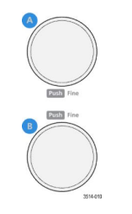

■ **Multipurpose knobs (A, B)** The Multipurpose knobs A and B move cursors and set parameter values in configuration menu input boxes. Selecting an input box that can use a Multipurpose knob assigns the indicated knob to change the value in that input box. The ring around each knob lights when you can use that knob to do an action. Push a Multipurpose knob to enable the Fine mode for making smaller increment changes. Push the knob again to exit Fine mode

**3. Trigger controls :**

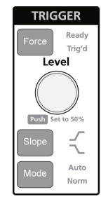

■ Force forces a trigger event at a random point in the waveform and captures the acquisition.

■ Level sets the amplitude level that the signal must pass through to be considered a valid transition. The color of the Level knob indicates the trigger source except for dual-level triggers. The Level knob is disabled when the trigger type requires two level settings or other trigger qualifiers (set from the Trigger configuration menu). Push the knob to set the threshold level to 50% of the peak-to-peak amplitude range of the signal.

■ Slope sets the signal transition direction to detect (low to high, high to low, or either direction). Push the button to cycle through the selections. The Slope button is disabled when the trigger type requires other slope qualifiers (set from the Trigger configuration menu).

■ Mode sets how the instrument behaves in the absence or presence of a trigger event.

■ Auto trigger mode enables the instrument to acquire and display a waveform whether or not a trigger event occurs. If a trigger event occurs, the instrument displays a stable waveform. If a trigger event does not occur, the instrument forces a trigger event and acquisition and displays an unstable waveform. Normal trigger mode sets the instrument to acquire and display a waveform only when there is a valid trigger event. If no trigger occurs, the last waveform record acquired remains on the display. If no last waveform exists, no waveform is displayed.

**4. Vertical controls :**

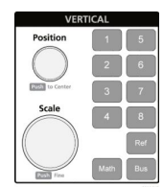

■ Position moves the selected waveform (Channel, Math, Reference, Bus) and its graticule up or down on the screen. The color of the Position knob indicates which waveform the knob is controlling. Push the knob to set the threshold level to 50% of the peak-to-peak amplitude range of the signal.

■ Scale sets the amplitude units per vertical graticule division of the selected waveform. The scale values are shown on the right edge of the horizontal graticule lines, and are specific to the selected waveform in both Stacked or Overlay modes (in other words, each waveform has its own unique vertical graticule settings regardless of display mode). The color of the Scale knob indicates which waveform the knob is controlling.

■ Channel buttons (1-4 for MSO54, 1-6 for MSO56, 1-8 for MSO58) turns on (displays), selects, or turns off a channel, as follows:

1. If the channel is not displayed, pushing a Channel button turns on that channel to the Waveform view.
2. If the channel is on the screen and is not selected, pushing that channel's button selects that channel.
3. If the channel is on the screen and is also selected, pushing that channel's button turns that channel off (removes it from Waveform view).

■ The Math button adds or selects a Math waveform on the Waveform view, as follows:

1. ■ If no Math waveform exists, pushing the Math button adds a Math waveform to the Waveform view and opens the Math configuration menu.
2. ■ If only one Math waveform is displayed, pushing the button turns off the Math waveform (removes it from Waveform view). Push the button again to display the waveform.
3. ■ If two or more Math waveforms are displayed, pushing the button cycles through selecting each math waveform.

**■ The** **Ref button** adds or selects a Reference (saved) waveform on the Waveform view, as follows:

■ If no Reference waveform exists, pushing the Ref button opens the Browse Waveform Files configuration menu. Navigate to and select a waveform file (*.wfm) and tap Recall to load and display the reference waveform.

■ If only one Reference waveform is displayed, pushing the button turns off the Reference waveform (removes it from the Waveform View). Push the button again to display the waveform.

■ If two or more Reference waveforms are displayed, pushing the button cycles through selecting each Reference waveform.

■ **The Bus button** adds or selects a bus waveform on the Waveform view, as follows:

■ If no Bus waveform exists, pushing the Bus button adds a Bus waveform to the Waveform view and opens the Bus configuration menu.

■ If only one Bus waveform is displayed, pushing the button turns off the Bus waveform (removes it from Waveform view).

■ If two or more Bus waveforms are displayed, pushing the button cycles through selecting each Bus waveform.

**5. Horizontal controls :**

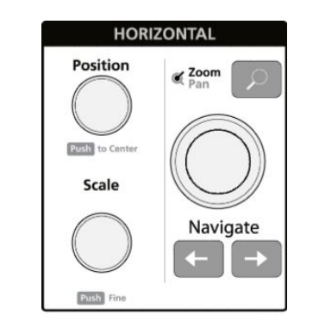

* **Position** moves the waveform and graticule side to side on the screen (changing the trigger point position in the waveform record). Push the knob to center the trigger event to the center graticule on the Waveform view.

**■ Scale** sets the time per major horizontal graticule division and samples/second parameters for the oscilloscope. Scale applies to all waveforms. Push the knob to enable the Fine mode for making smaller increment changes. Push the knob again to exit Fine mode.

■ **Zoom** opens the Zoom mode.

**■ Zoom knob (ce9nter knob)** increases or decreases the area of the zoom box in the Zoom Waveform Overview, which in turn controls the zoom amount of the waveforms shown in the main Zoom view.

■ **Pan knob (outer knob)** moves the Zoom box left or right in the Zoom Waveform Overview, which in turn controls the part of the waveform shown in the main Zoom view.

■ **Navigate (left and right arrow)** buttons puts the oscilloscope in Zoom mode and positions the previous or next search point in the waveform record to the center graticule of the Waveform view. There must be a Search badge present in the Results bar before the Navigate function will operate

**6. Miscellaneous controls:**

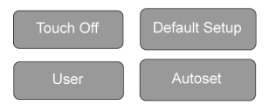

**■ Touch Off** turns touch screen capability off. The Touch Off button is lighted when the touch screen is turned off.

**■ User** is a one-push save operation that uses the current menu bar File > Save As settings to save screen shots (including open menus and dialog boxes), waveform files, instrument settings, and so on, as follows:

■ If a File > Save or File > Save As operation has occurred since the last instrument startup, pushing User saves the file types to the location last set in the Save As configuration menu.

■ If no file save operation has occurred since the last instrument startup, pushing User opens the Save As configuration menu. Select a tab to select what type of file to save (Screen Capture, Waveform, and so on), set any associated parameters, and where to save it, and select OK. The specified file or files are saved. The next time you push User, the specified files are saved.

■ **Screen Captures** capture the entire screen, including most displayed configuration menus and dialog boxes.

■ **Default Setup** restores the oscilloscope settings (horizontal, vertical, scale, position, and so on) to the factory default settings.

**■ Autoset** automatically displays a stable waveform

**7. Ground and Probe Compensation connectors:**

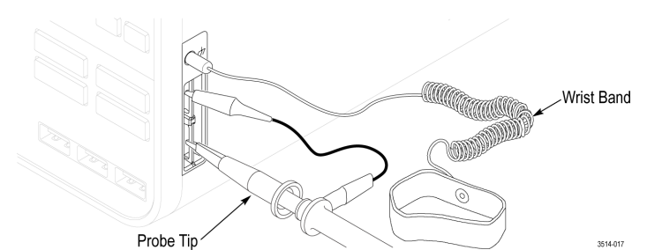

■ **The Ground and Probe Compensation connectors** are located at the lower right side of the instrument, near the front panel. The Ground connector (the small hole in the case) provides an electrically grounded (through a resistor) connection point to attach an anti-static wrist strap, to reduce electrostatic damage (ESD) while you handle or probe the DUT.

■ **The Probe Compensation connections** provide a ground connector (upper tab) and 1 kHz square wave source (lower tab) for adjusting the high-frequency response of a passive probe (probe compensation). The oscilloscope uses this signal to automatically compensate supported probes, including the ones that ship with the product

**8. USB Host ports (USB 3.0 and 2.0):**

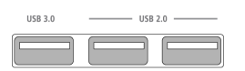

**■ USB ports** are located at the lower right corner of the front panel, and on the rear panel. Connect USB flash drives to which you can save or recall data (such as instrument software updates, waveforms, settings, and screen captures), or connect peripheral devices such as a mouse or keyboard.

**9. FlexChannel probe connectors:**

■ FlexChannel connectors support all TekVPI+ and TekVPI measurement probes, BNC passive probes, the TPL058 FlexChannel Logic Probe, and BNC cables. You connect most probes simply by pushing them into the connector until the probe seats with a click.

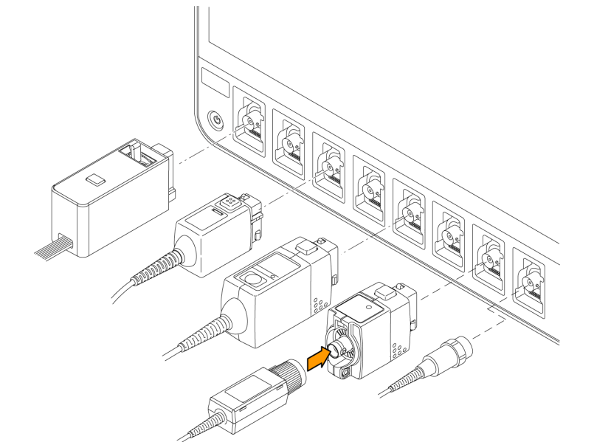

**Rear panel connections :**

The rear panel connections supply power to the oscilloscope and provide connectors for network, USB devices, video, reference signals, and the AFG output.

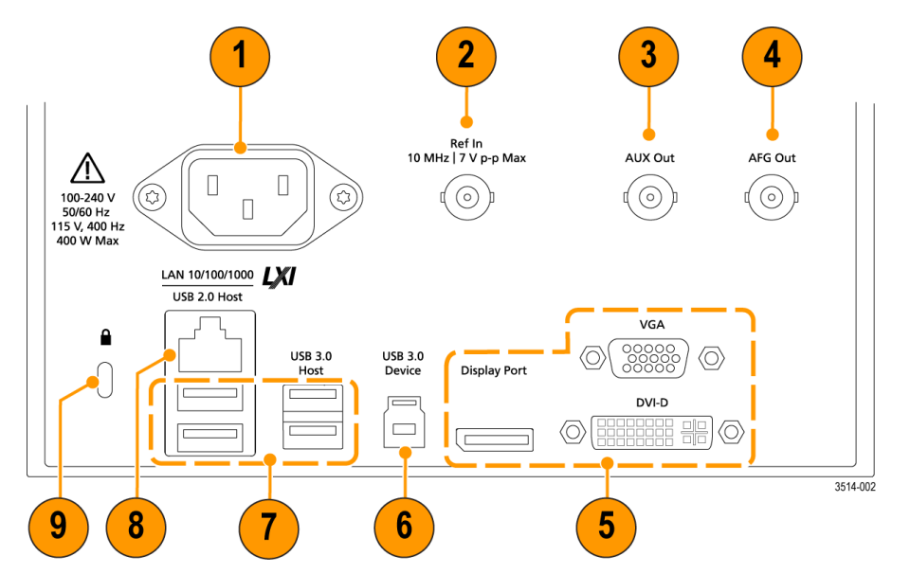

1. **Power cord connector**. Use only the power cord specified for this product and certified for the country of use.

2. **Ref** In lets you connect a high-precision 10 MHz reference signal to the oscilloscope for more accurate measurements.

3. **AUX Out** generates a signal transition on a trigger event, outputs a 10 MHz reference signal, or outputs a synchronization signal from the AFG.

4**. AFG Out** is the signal output for the Arbitrary Function Generator (AFG).

5. **Video outputs** (Display Port, VGA, and DVI-D) let you connect an external monitor or projector to show the oscilloscope screen.

6. **USB Device port** lets you connect to a PC to remotely control the oscilloscope using USBTMC protocol.

7. **USB Host ports** let you connect a USB memory device, keyboard, or mouse.

8**. LAN connector (RJ-45)** connects the oscilloscope to a 10/100/1000 Base-T local area network.

9**. Security lock connector** lets you use a standard PC/laptop lock cable to secure the oscilloscope to a work bench or other location.